# **Test Plan - OpenCart**

**Test Plan - OpenCart** 1

1. Introduction 1

2. Objective and Scope 2

2.1 Objective 2

2.2 In Scope 2

2.3 Out of Scope 2

3. Testing Strategy 3

4. Quality Objective 3

5. Resourcing and Roles 4

6. Test Deliverables 4

7. Test Environment 5

8. Defect Reporting Procedure 5

9. Entry and Exit Criteria 5

9.1 Requirement Analysis 5

Entry Criteria: 5

Exit Criteria: 5

9.2 Test Execution 5

Entry Criteria: 5

Exit Criteria: 6

9.3 Test Closure 6

Entry Criteria: 6

Exit Criteria: 6

10. Risks and Mitigations 6

11. Approvals 6

## 1. Introduction

In this document of the Test Plan for the OpenCart application, which is an e-commerce website for online shopping. Any user can create an account, log in and choose the required commodity or product from the listed categories. Also, the customer can see the reviews which aid him/her to choose the right product from the available options.

## 2. Objective and Scope

### 2.1 Objective

The plan identifies the module to be tested, the type of testing to be performed, the test strategy, personnel responsible for testing, the resources and schedule required to complete testing, and the risks (if any) associated with the plan.

### 2.2 In Scope

Features mentioned in requirement document only are to be tested which includes the user registration page testing including all fields.

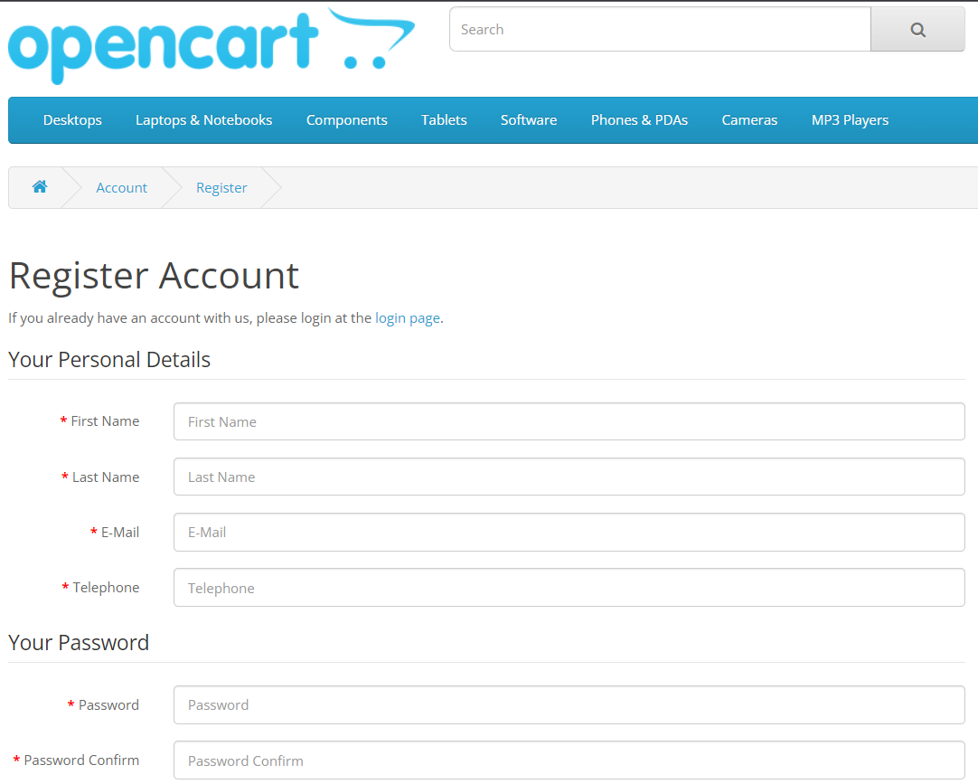

### 2.3 Out of Scope

Following features but not limited to are not to be tested because they are not included in the software requirement specifications.

* User Interfaces
* Performance
* Website Security

## 3. Testing Strategy

* The first step is to create test scenarios based on priority and test cases for the various features in scope.
  + While developing test cases, we'll use several test design techniques like

1. Decision Table Testing
2. Use Case Testing
3. Boundary Value Analysis
   * We also use our expertise in creating Test Cases by applying the below:
   1. Error anticipation
   2. Exploratory Testing

* Second step includes testing procedure when we receive a request for testing:

1. First, we'll conduct smoke testing to see if the various and important functionalities of the application are working.
2. We reject the build if the Smoke Testing fails and will wait for the stable build before performing in-depth testing of the application functionalities.
3. Once we receive a stable build, verified by Smoke Testing, we perform in-depth testing using the Test Cases developed.
4. Multiple Test Resources will be testing the same Application on Multiple Supported Environments simultaneously.

* We then report the defects in bug tracking tool and follow defect life cycle procedure.
* As part of the Testing, we will perform the below types of Testing:

1. Smoke Testing and Sanity Testing
2. Regression Testing and Retesting
3. Usability Testing, Functionality & UI Testing

* We repeat Test Cycles until we get the quality product.
* The best practices to be followed to make our Testing better:
  1. **Context Driven Testing** – We will be performing Testing as per the context of the given application.
  2. **Shift Left Testing** – We will start testing from the beginning stages of the development itself, instead of waiting for the stable build.
  3. **Exploratory Testing** – Using our expertise we will perform Exploratory Testing, in addition to the normal execution of the Test cases.
  4. **End to End Flow Testing** – We will test the end-to-end scenario which involves multiple functionalities to simulate the end user flows.

## 4. Quality Objective

The test scenarios aim to **verify** the functionality of user registration module in Open cart webpage, focused to test the **user registration or creation of account** such as Unique Account creation, duplicate account creation, etc. to **guarantee** all these operations can work as expected in real business environment.

The types of testing to be performed: manual testing or automated testing, integration testing.

## 5. Resourcing and Roles

The project should use outsource members as the tester to save the project cost.

|  |  |  |
| --- | --- | --- |
| **Sl No** | **Resource** | **Task** |
| 1. | Test Manager | Manage the whole project Define project directions |
| 2. | Tester | Verify and assess the Test Approach Execute the tests, Log results, Report the defects. Outsourced members |
| 3. | Developer in Test | Implement the test cases, test suites etc. |
| 4. | Test Administrator | Set up test environment and manage assets.  Support Tester to use the test environment for test execution |
| 5. | SQA members | Take in charge of quality assurance Check to confirm whether the testing process is meeting specified requirements |

## 6. Test Deliverables

Test deliverables are provided to client as below.

**Before testing phase**

* Test plan document.
* Test cases document.
* Test Design specifications.

**During the testing**

– Test Data

– Test Trace-ability Matrix – Error logs and execution logs.

**After the testing cycles**

* Test Execution reports
* Defect Reports
* Installation/ Testing procedure guidelines
* Release notes

## 7. Test Environment

It mentions the minimum hardware and software requirements that will be used to test the Application.

Following software’s are required in addition to client-specific software.

* Windows 10 or above
* Chrome/Firefox
* Robot Framework with Selenium Library and PyCharm.

## 8. Defect Reporting Procedure

The criteria for identifying a defect, such as deviation from the requirements, user experience issues, or technical errors.

The **steps for reporting a defect- Log in Test Management tool** providing detailed reproduction steps and attaching screenshots or logs.

The **process for triaging and prioritizing defects-** Assigning severity and priority and assigning them to the appropriate team members for investigation and resolution.

The **tools and systems** that will be used for tracking and managing defects- Azure DevOps (TFS).

The **communication channels a**nd frequencies for updating stakeholders on the progress and status of defects – MS Teams meeting/calls bi-weekly.

## 9. Entry and Exit Criteria

The below are the entry and exit criteria for every phase of Software Testing Life

Cycle:

### 9.1 Requirement Analysis

#### Entry Criteria:

• Once the testing team receives the Requirements Documents or details

about the Project

#### Exit Criteria:

• List of Requirements are explored and understood by the Testing team

• Queries are cleared

### 9.2 Test Execution

#### Entry Criteria:

• Test Scenarios and Test Cases Documents are signed-off by the Client

• Application is ready for Testing with stable build.

#### Exit Criteria:

• Test Case Execution Reports, Defect Reports are ready.

### 9.3 Test Closure

#### Entry Criteria:

• Test Case Reports, Defect Reports are ready.

#### Exit Criteria:

• Test Summary Reports are generated.

## 10. Risks and Mitigations

The following are the list of risks possible and the ways to mitigate them:

1. Risk: Non-Availability of a Resource

Mitigation: Backup Resource Planning

1. Risk: Build URL is not working

Mitigation: Resources will work on other tasks

1. Risk: Less time for Testing

Mitigation: Ramp up the resources based on the Client needs dynamically

## 11. Approvals

Team will send different types of documents for Client Approval like below:

• Test Plan

• Test Scenarios

• Test Cases

• Reports

Testing will only continue to the next steps only if these approvals are done.